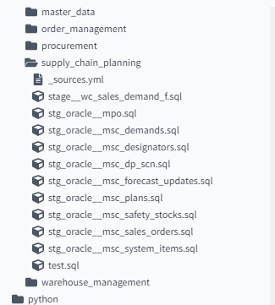

Staging of sales_Demand_F

Files